**Notes for Sections 8.2 and 11.1-11.4**

* Lecture Notes
  + Digital logic/binary logic
    - A 2 state physical device has the least difficulty in maintaining state separation.
    - 0 and 1, typically based on low and high voltage
  + Levels of abstraction
    - Transistors on/off -> log gates (or) -> logic circuits (adder) -> components (ALU)
    - Will need conventions such as number representation, signed number representation, character codes.
  + Types of logic
    - Combinational logic
      * No memory involved, output depends only on input
    - Sequential logic
      * Memory involved, output depends on past sequence of inputs as well as current input.
  + Boolean Algebra
    - All variables have value either 1 or 0
    - Three operations
      * Logical Product
        + "and", "*", middle dot ("·"), conjunction symbol ("∧", called wedge, caret, or circumflex)
        + also the operation is implicit when two single-letter variables are written together (" AB ")
      * Logical Sum
        + or", "+", disjunction symbol ("∨", called vee or reversed caret)
        + a single vertical bar ("|")
      * Inversion/Complement
        + prefix of "not", "~", "¬", “!”, “/”; a bar across the top of a variable or term ("A "); an apostrophe as suffix (" A’ ")
      * any function can be written as a formula involving the three operations (see also universal sets below)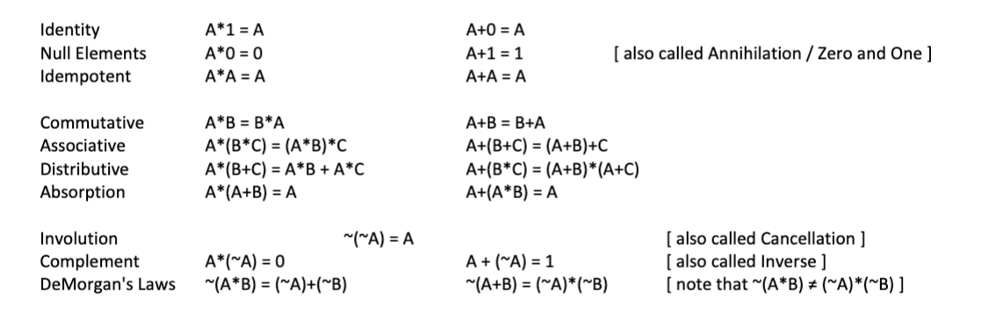
  + Logic Expressions
    - Literal
      * The use of a single logic variable, in true or inverted form
      * A or ~A, etc
    - Product Term
      * A logic expression having only logical product operations
    - Minterm
      * A product term having exactly one literal for each input variable
  + Truth Table
    - Completely describes a logic function table
    - The count of rows is 2 to the number of inputs which equals one row for each possible minterm
    - Contains an exhaustive enumeration of input permutations
    - K-Maps (Karnaugh Maps) are specially formatted versions of truth tables
    - 16 Possible functions of two input variables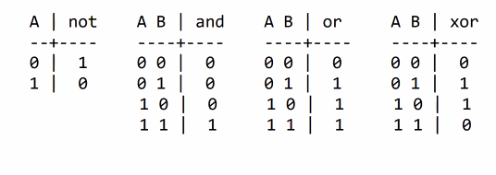
    - Xor is a circled plus
  + Universal Operation Set
    - {and, or, not}
    - {and, not}
    - {nand}
      * Nand = not and
    - {or, not}
    - {nor}
      * Nor = not or
  + Canonical forms
    - Sum of products
      * Sum of minterms is logical sum of all truth table rows with an output of 1
    - Product of sums
    - Sum of products is usually the easiest to manipulate
  + Sum of minterms table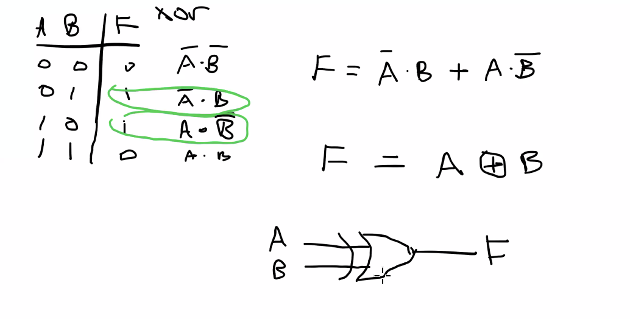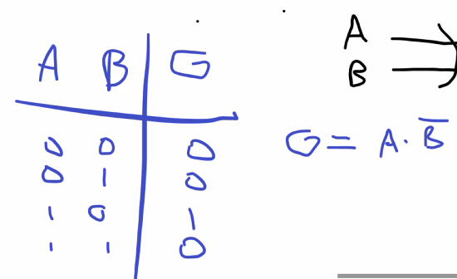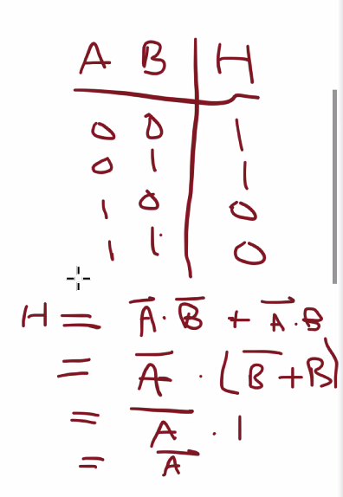
* Electronics and digital systems 11.1
  + Electrical System
    - Involves movement of charged electrons through wires
    - They are ubiquitous in appliances, computers, cars, etc.
  + Voltage
    - The potential for charge to move
    - Voltage is measured in Volts.
    - Like the water pressure in a faucet for a garden hose.
  + Current
    - The amount of charge flow.
      * Current is measured in Amps.
    - Like the amount of water actually flowing through the hose.
  + Resistance
    - A wire’s opposition to flow
    - Resistance is measured in Ohms.
    - Like a thin hose more-strongly resisting flow than a thick hose.
  + An example of an electrical system is a lamp that passes current through a glowing resistor in a light bulb.
    - The more current, the brighter the glow.
    - Without current the bulb doesn’t glow.
    - Voltage causes current, so the bulb glows.
    - Higher voltage causes more current so therefore brighter glow.
  + Current flows from a higher voltage point to a lower voltage point on a wire.
    - 0 V is commonly called **ground**.
  + Voltage (V), current (I), and resistance (R) are related as V = IR.
    - This is called **Ohm’s law.**

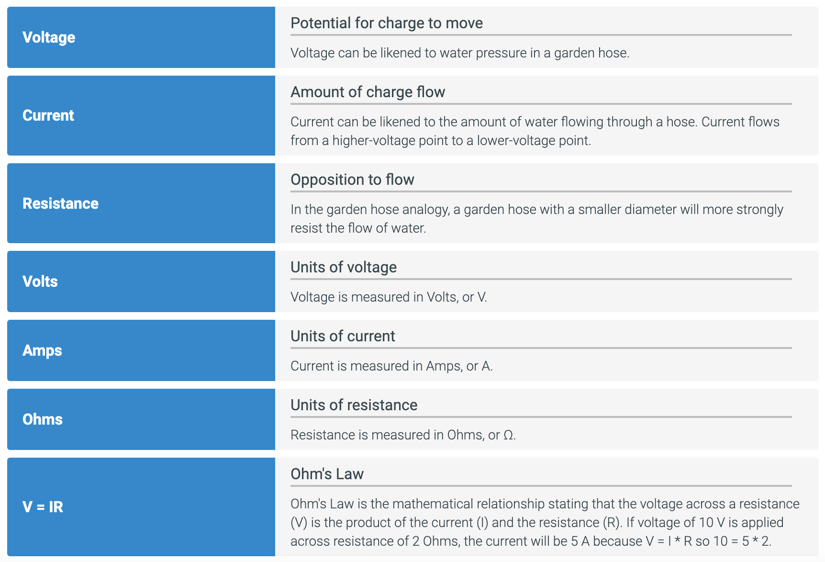

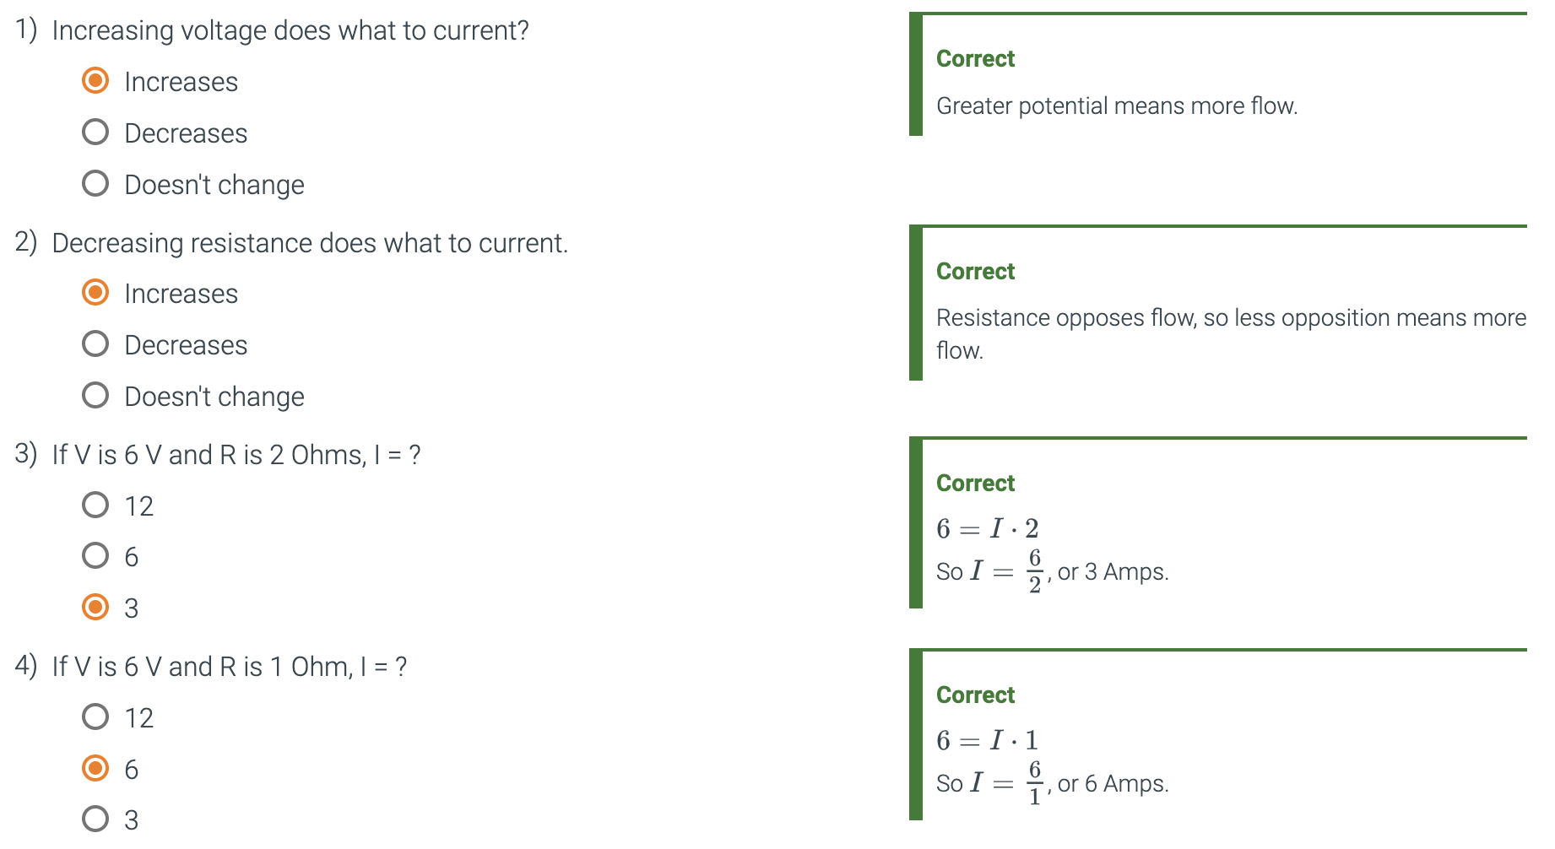

* + The voltage on a wire with no resistance is the same everywhere on the wire. But voltage drops across a resistor as V = IR.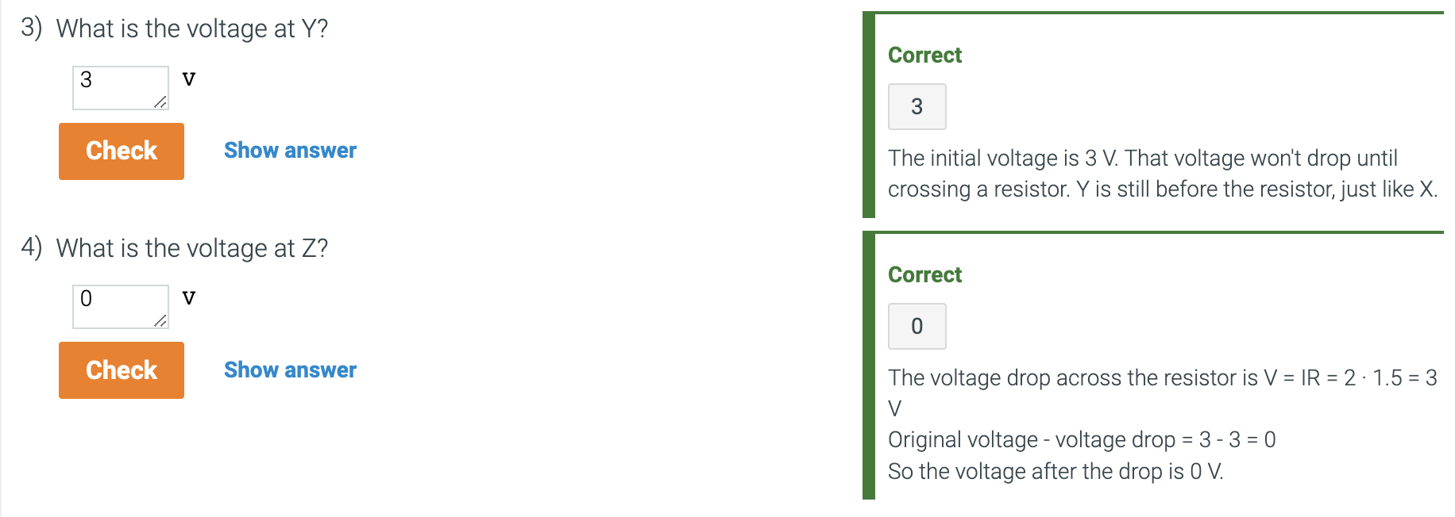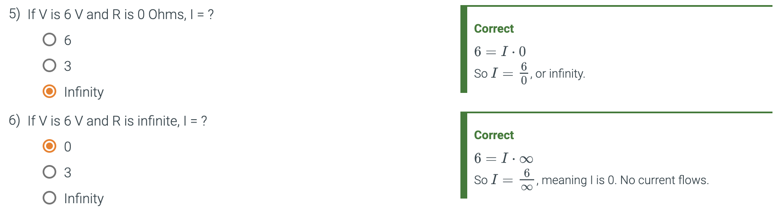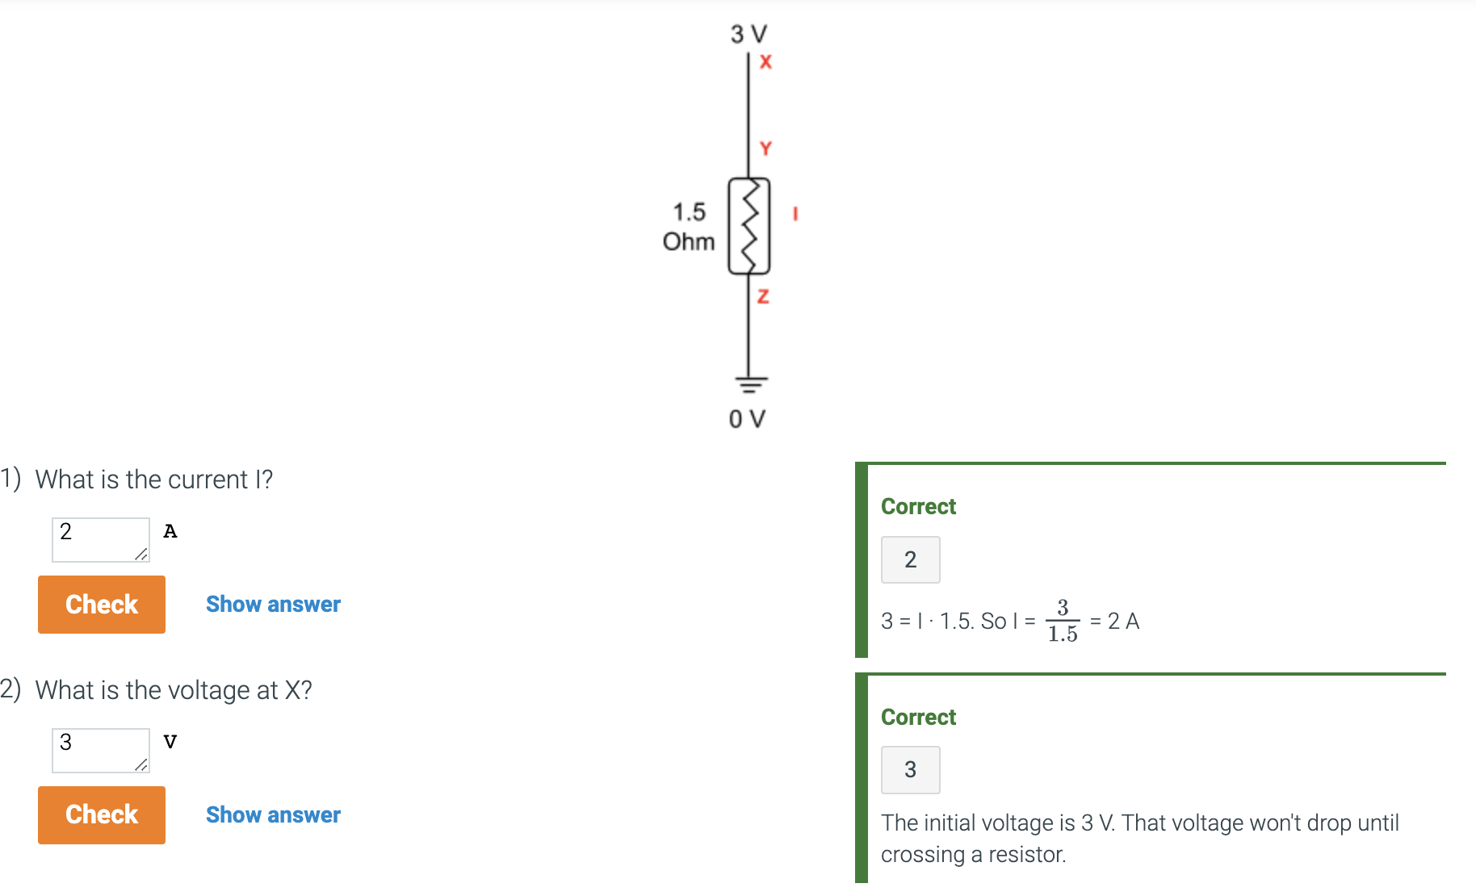
  + Nearly every wire has some tiny resistance (with the exception of superconductors), but that resistance is commonly ignored
  + Convention is to show current flowing from higher voltage to lower voltage, even though actual flow is in the other direction, due to electrons having negative charge. But the net effect is the same.
  + Switches
    - Switch
      * An electronic device that acts like a wire (conducts) between two terminals if the switch is configured to on.
      * A light switch is an example.
      * A light switch can be configured to conduct current.
      * In the on position, the switch conducts, so the bulb glows.
      * In the off position, the switch does not conduct, so bulb does not glow.
    - Electronically controlled switch
      * Has another input terminal whose voltage can turn the switch on.
      * The terminal that controls electronically controlled switches is known as the **control input.**
      * An electronically-controlled switch has a control input that turns the switch on or off.
      * A positive voltage on the control input turns the switch on.
      * 0 V on the control input turns the switch off.
    - Switches were several inches long in the early 1900s.
    - Transistor
      * A smaller, simpler switch with no mechanical parts, invented in 1947.
  + CMOS Technology
    - Uses pMOS and nMOS transistors to implement digital circuits.
    - The C in CMOS refers to nMOS and pMOS being complementary
    - nMOS
      * A transistor that conducts when the control input is 1.
    - pMOS
      * A transistor that conducts when its control input is 0.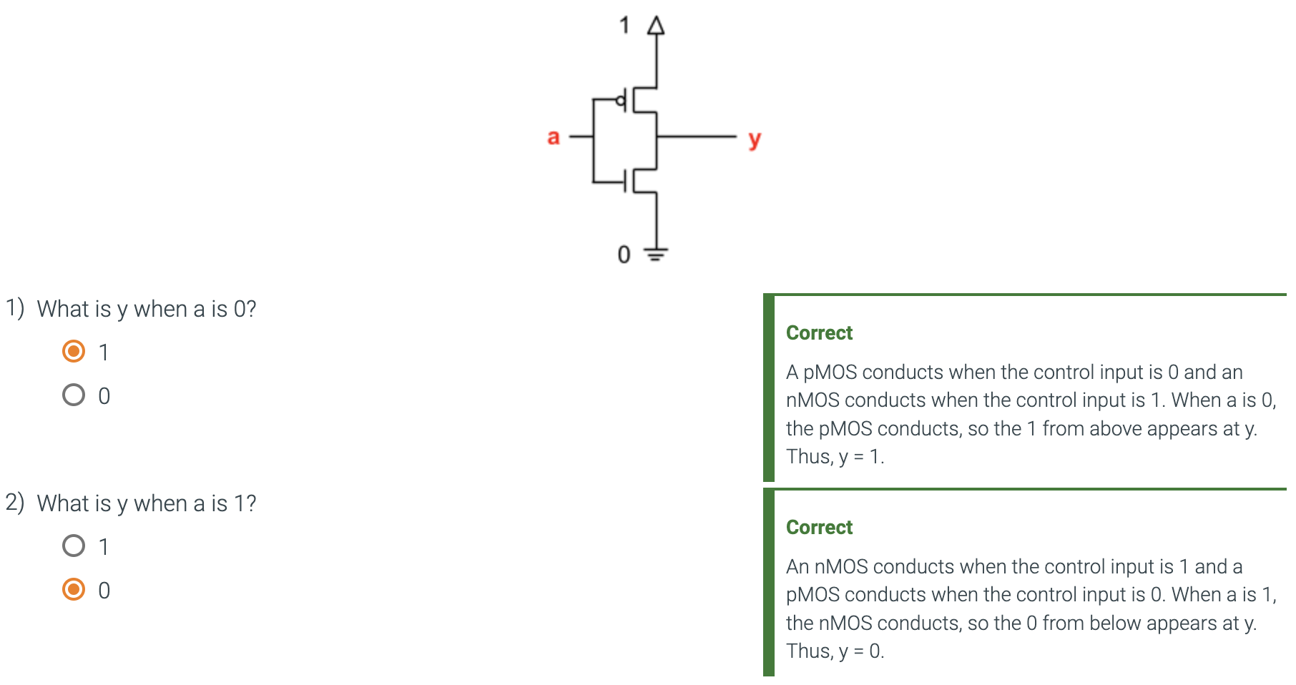
  + Digital Systems
    - Circuit
      * A path through which electrical current can flow
      * In a circuit of switches, some wires have a high voltage and some have low voltage
    - Digital Circuit
      * Has voltages that are treated as either high or low.
        + Typically built as a connection of switches.
      * Form the basis of useful systems like smartphones, computers, medical devices.
      * Usually referred to as digital systems.
    - Analog System
      * Has voltages that are treated as having infinite values like 0.15, 0.2, 0.33, etc.
      * Treats voltages as continuous.
    - Digital Design
      * Creating digital circuits to achieve desired digital system behavior that converts digital inputs into desired digital outputs.
* Gates 11.2
  + Logic Gate
    - A transition circuit that implements a logic function
  + NOT Gate (inverter)
    - Outputs 1 if the gate’s input is 0, and outputs 0 if the input is 1.
    - A NOT gate is also called an **inverter.**
    - NOT Gate built from CMOS transistors.
      * An input of 0 causes the pMOS transistor to conduct, and the nMOS transistor to not conduct. Thus, y becomes 1.
      * An input of 1 causes the nMOS transistor to conduct, and the pMOS transistor to not conduct. Thus, y becomes 0.
  + AND Gate
    - Outputs 1 only if both gate’s inputs are 1’s
    - An AND Gate is built by inverting the output of a NAND gate.
    - Input (0, 0) yields an output of 0.
    - Input (0, 1) yields an output of 0.
    - Input (1, 0) yields an output of 0.
    - Input (1, 1) yields an output of 1.
      * An AND gate’s output is 1 only when the gate’s first and second inputs are 1.
  + pMOS is a poor conductor of 0’s.
    - We do not know why; the physics is out of our scope.
  + nMOS is a poor conductor of 1’s.
    - We do not know why; the physics is out of our scope.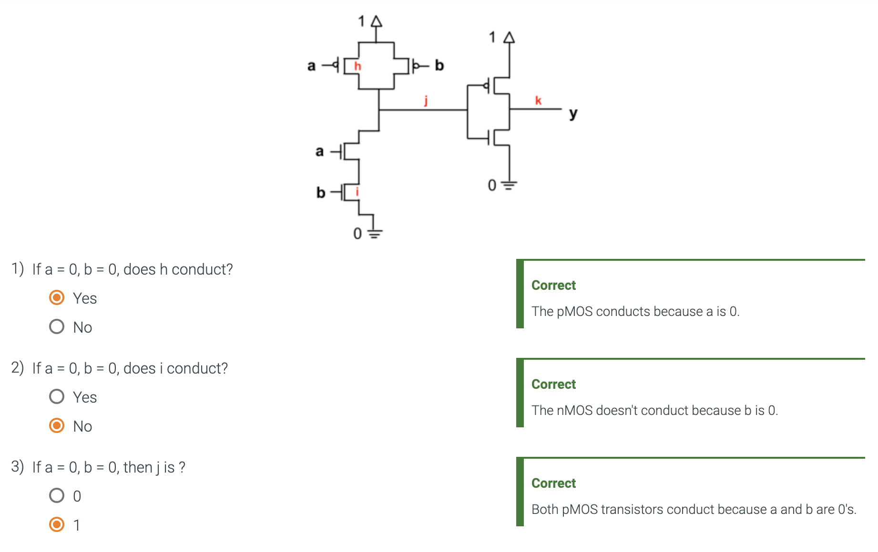
  + OR Gate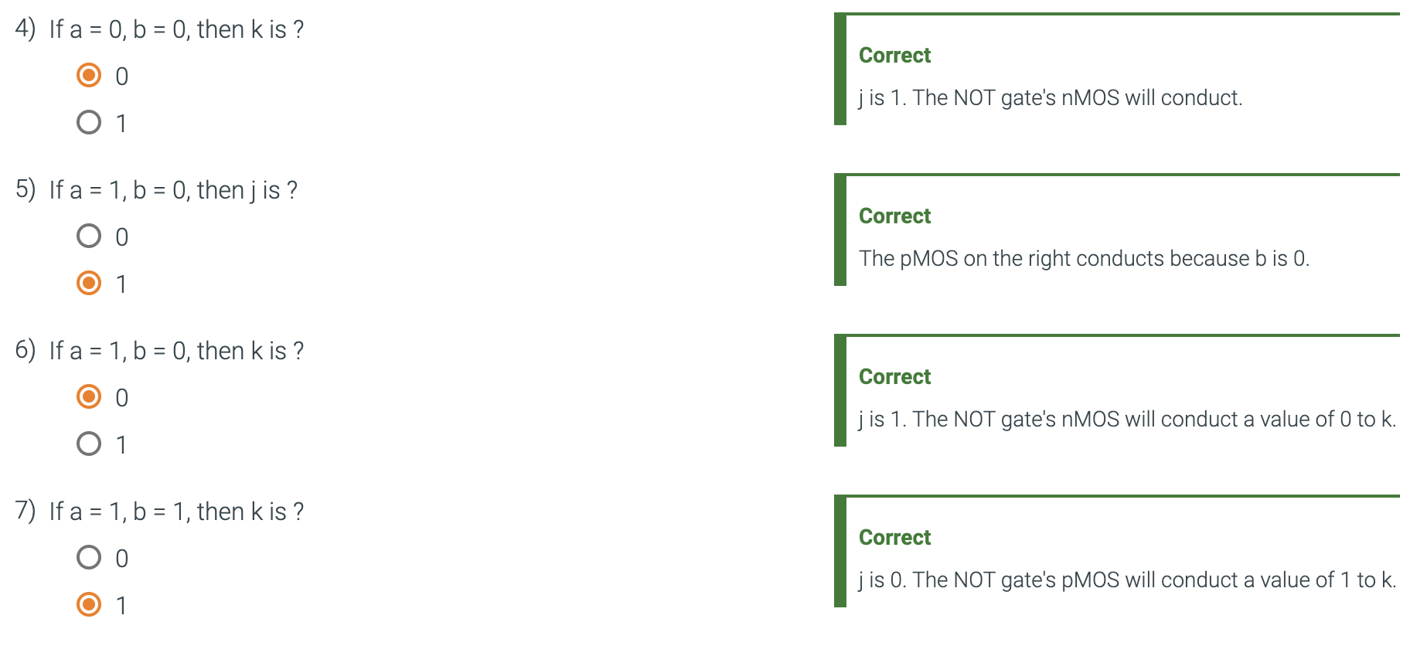
    - Output 1 if either or both of the gate’s input is a 1.
    - An OR gate is built by inverting the output of a NOR gate.
    - Inputs (0, 0) yields an output of 0.
    - Inputs (0, 1) yields an output of 1.
    - Inputs (1, 0) yields an output of 1.
    - Inputs (1, 1) yields an output of 1.
    - Only one input needs to be 1 for the output to be 1.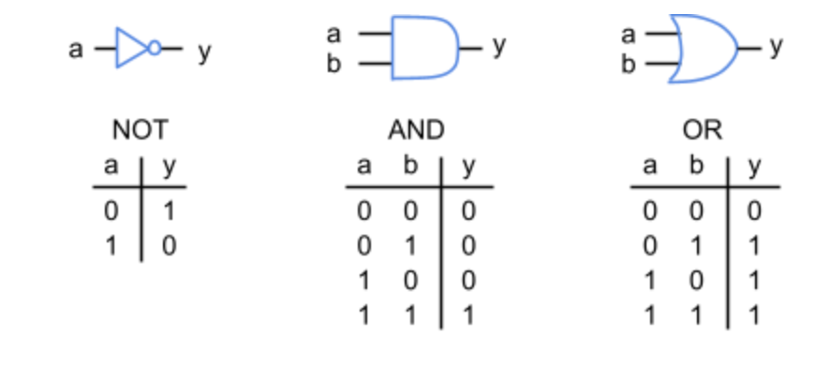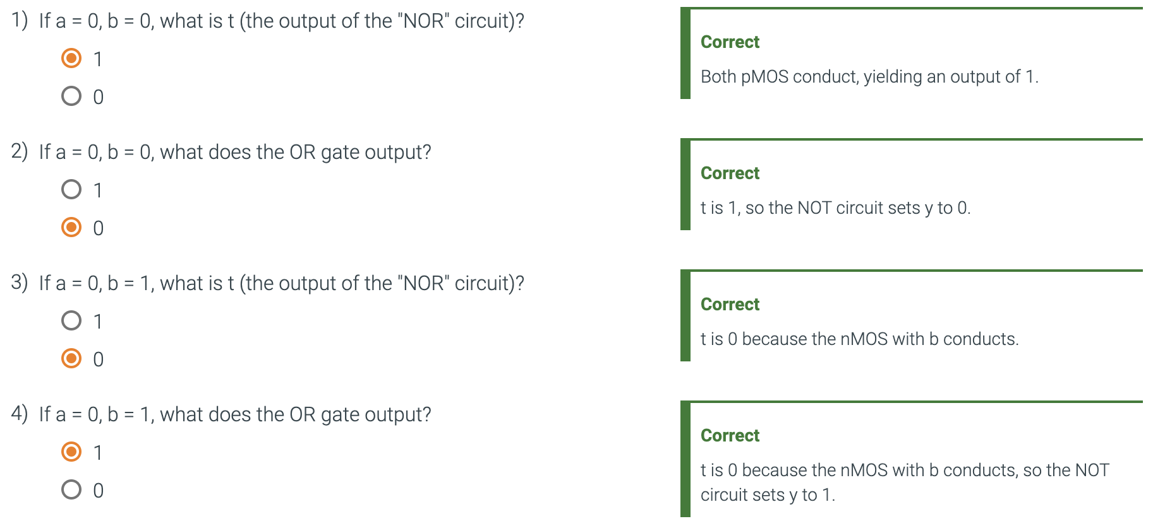
* Boolean Algebra and Equations 11.3
  + Boolean Algebra
    - An algebra whose only values are true and false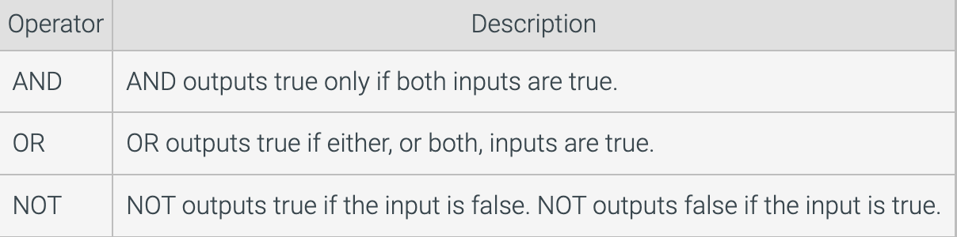
    - And whose operators are AND, OR, and NOT (Logic operators)
  + Boolean Equation
    - Has a Boolean variable (left), an equal sign, and a Boolean expression (right), defining the left variable's value based on the right variables' values.
    - A Boolean equation can describe a digital circuit, with the output on the left and the inputs on the right.
    - A digital system has inputs, outputs, and goal behavior. This microwave should open the door (d) if button (b) is pressed and motor (m) is not running.
    - The behavior can be captured as the equation: **d = b AND NOT(m).**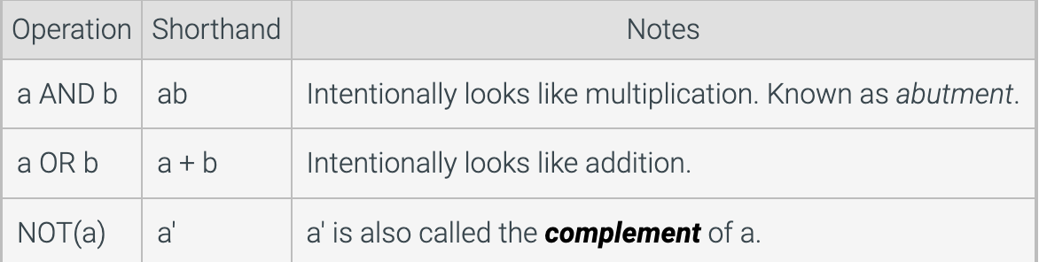
  + Digital circuits are sometimes called logic circuits due to the roots in Boolean algebra's logic operations of AND, OR, and NOT.
  + Function
    - A relation of inputs' values to an output's values.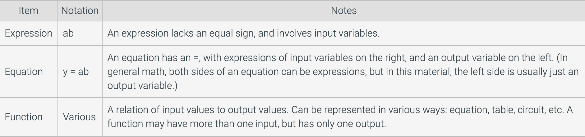
    - A function defines exactly one output value for unique input values.
    - A function must include all input possibilities.